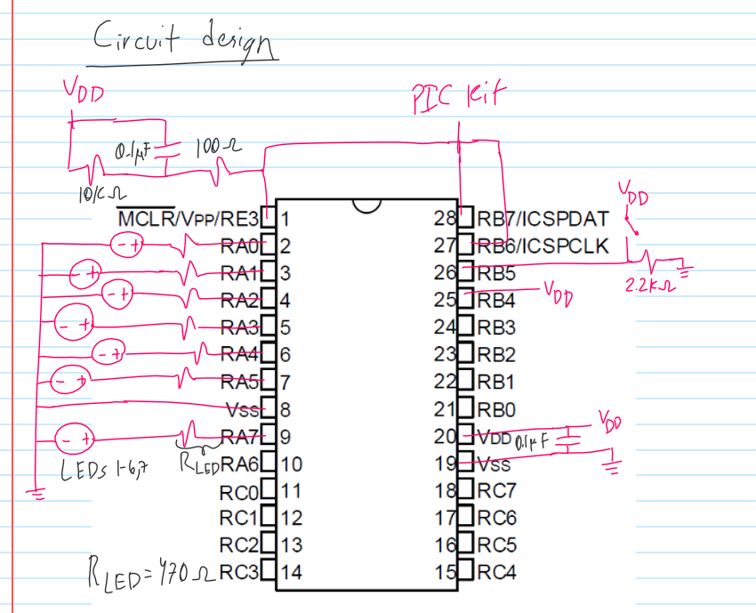

Code Design

Initialization

Configure TRISA (output), ANSELA (digital), PORTA (only RA7 on), TRISB (input), and ANSELB (digital).

While (1)

{

If RB5 goes from LOW to HIGH (button is pressed, to check compare previous RB5 state to current RB5 state).

{

If RA5-RA0 are HIGH.

{

Set them LOW.

}

Else

{

LED counter + 1.

}

}

Store new “previous” RB5 state.

}